**Scaling the Summit**

**Team Contact**: Niralya Sundararajan

**Tech Students:**

James Cannon: [jmcannon2@wpi.edu](mailto:jmcannon2@wpi.edu)

Niralya Sundararajan: [nsundararajan@wpi.edu](mailto:nsundararajan@wpi.edu)

Han Saparuly: [bsaparuly@wpi.edu](mailto:bsaparuly@wpi.edu)

**Art Students:**

Griffin Bowers [gbowers@wpi.edu](mailto:gbowers@wpi.edu) [griffinbowers20@gmail.com](mailto:griffinbowers20@gmail.com)

Lauren Waddick: [lewaddick@wpi.edu](mailto:lewaddick@wpi.edu) [waddicklauren@gmail.com](mailto:waddicklauren@gmail.com)

Juliet Morin: [jmorin2@wpi.edu](mailto:jmorin2@wpi.edu) [julietcmart@gmail.com](mailto:julietcmart@gmail.com)

**Elevator Pitch**:

A 3-D collect-a-thon traversal game revolving around a lizardman who is attempting to scale a mountain. As you progress the game by collecting runes (or power-ups), you can access further areas which will allow you to steadily scale the mountain.

**Game Overview:** (Detailed Description)

* Where and when does the game take place?

Foggy mountain setting with a magic system similar to medieval fiction with runes (power ups) that change the player’s physiology to grant abilities similar to those of some real-life lizards. On the mountain there is an abandoned mining village that you traverse through to fix a gondola in order to get down the mountain.

* Who/what are the protagonist and adversary (which one is the player)?

The protagonist: A bipedal lizard-man who is attempting to scale down a mountain by collecting parts to fix a gondola. They use various lizard abilities gained from exploration.

Adversary: Magic golems that have been reactivated after years to discover how to escape the mountain mine they have awoken in.

* Explain the primary objective of the player and how the player wins.

The player wins by successfully rebuilding the gondola after collecting the parts, which spawn in (potentially) random places that you have to find that are different each playthrough. A subgoal would be that the player has to collect all their abilities, as it should not be possible to collect the parts without getting all abilities. A discussed secondary goal would be to complete it within a certain timeframe.

* Explain the general game narrative (if any) in 1‐2 paragraphs

The lizardman needs to find out why this mountain village has been abandoned and why they are the only one on the mountain. There will be traces of environmental storytelling through collection of the gondola parts (either through item descriptions or notes found in the world).

As we have thought it out so far, the general background story was that the mining village is abandoned due to an attack from a dragon who contested the territory. The golems are defense systems created by those villagers through magic. Protag is the child of the dragon who hatched after the two sides destroyed each other.

* What is the basic game mechanic? (Use visuals, as appropriate)

The player will have various abilities that they switch between that they get from runes within the game. The abilities are based off of real life lizards, such as -

Gliding (Frilled Lizards)

Running on water (Basilisks)

Camouflage (Chameleons)

Their starting ability will be using their tongue as a grappling hook.

**Expected Art Assets**: <https://docs.google.com/spreadsheets/d/1CwkzSOSgABzFVBj4ajLAGSrMwmnqaMFL30xNGFacrGw/edit#gid=0>

* Player Model, fully textured and rigged with animations for:
  + Idle
  + Walking
  + Running
  + Jumping
  + Tongue Grapple?
  + Climbing?
  + Gliding?
  + Hover/Levitating?
* Enemy models, Stone Golems, fully textured with a few animations
  + Walk
  + Idle
  + Attack
* Start menu
* Pause menu
* 2-3 distinct buildings (village huts made from wood)
* Rocks
* Vegetation (trees, bushes, vines)
* Stone stairs
* Platforms
* Tileable pathways
* Ground Torch
* Runes
* Mechanical parts (picked up to fix gondola)
* Gondola (broken, fixed)
* Gondola lift mechanism, cables

**Expected Tech Requirements**:

* Physics:
  + Gravity
  + Swinging
  + Gliding (Air resistance?)
* AI/Pathfinding: Golems
* UI for runes/abilities and item descriptions
  + Menus for changing lizard form
* Walking mechanics:
  + Over water
  + Through the air (Gliding)
  + Enemy movement (Golems)
* Camera with free spinning and player controlled rotation

**Sketches:**

**Lizard:**

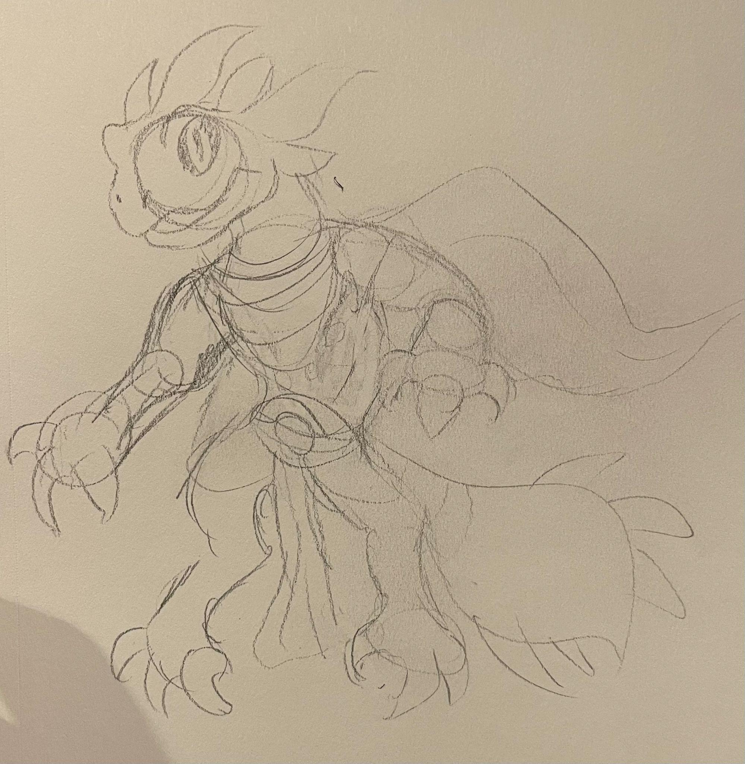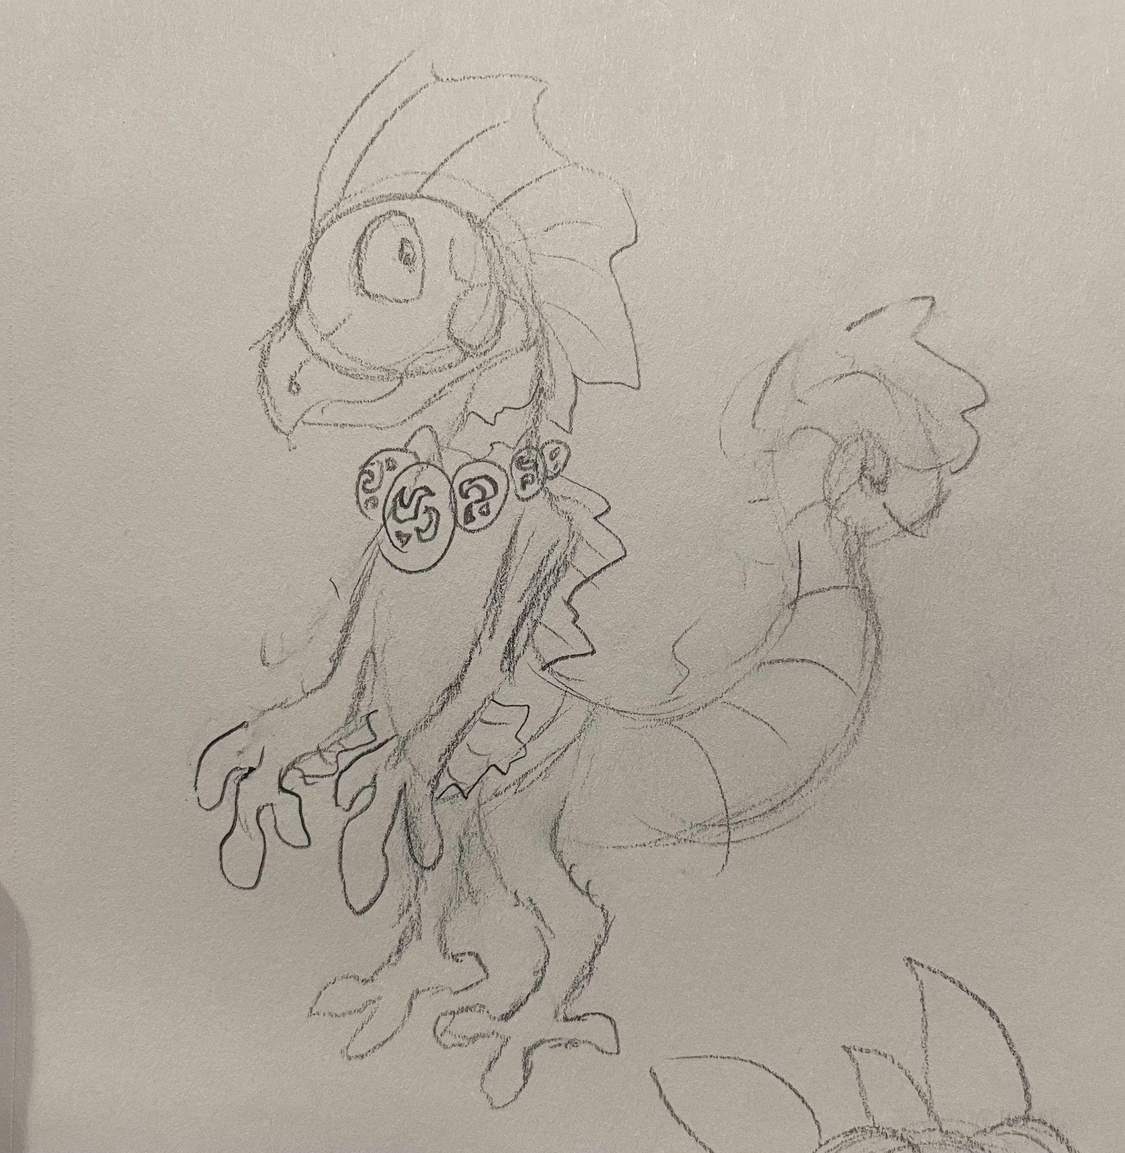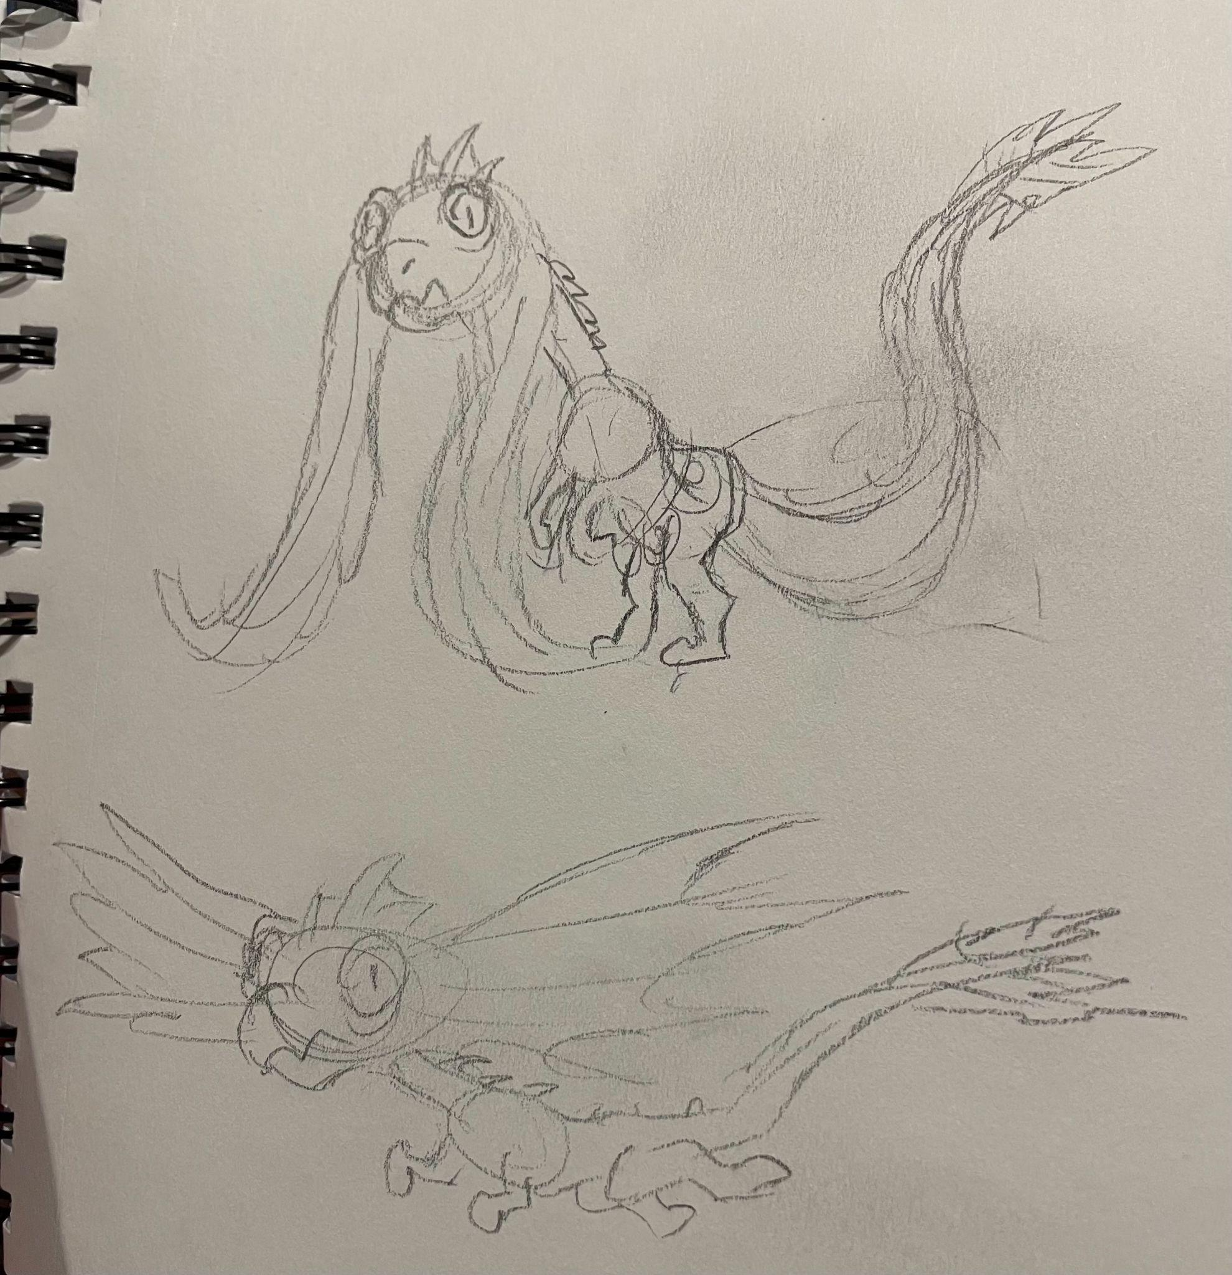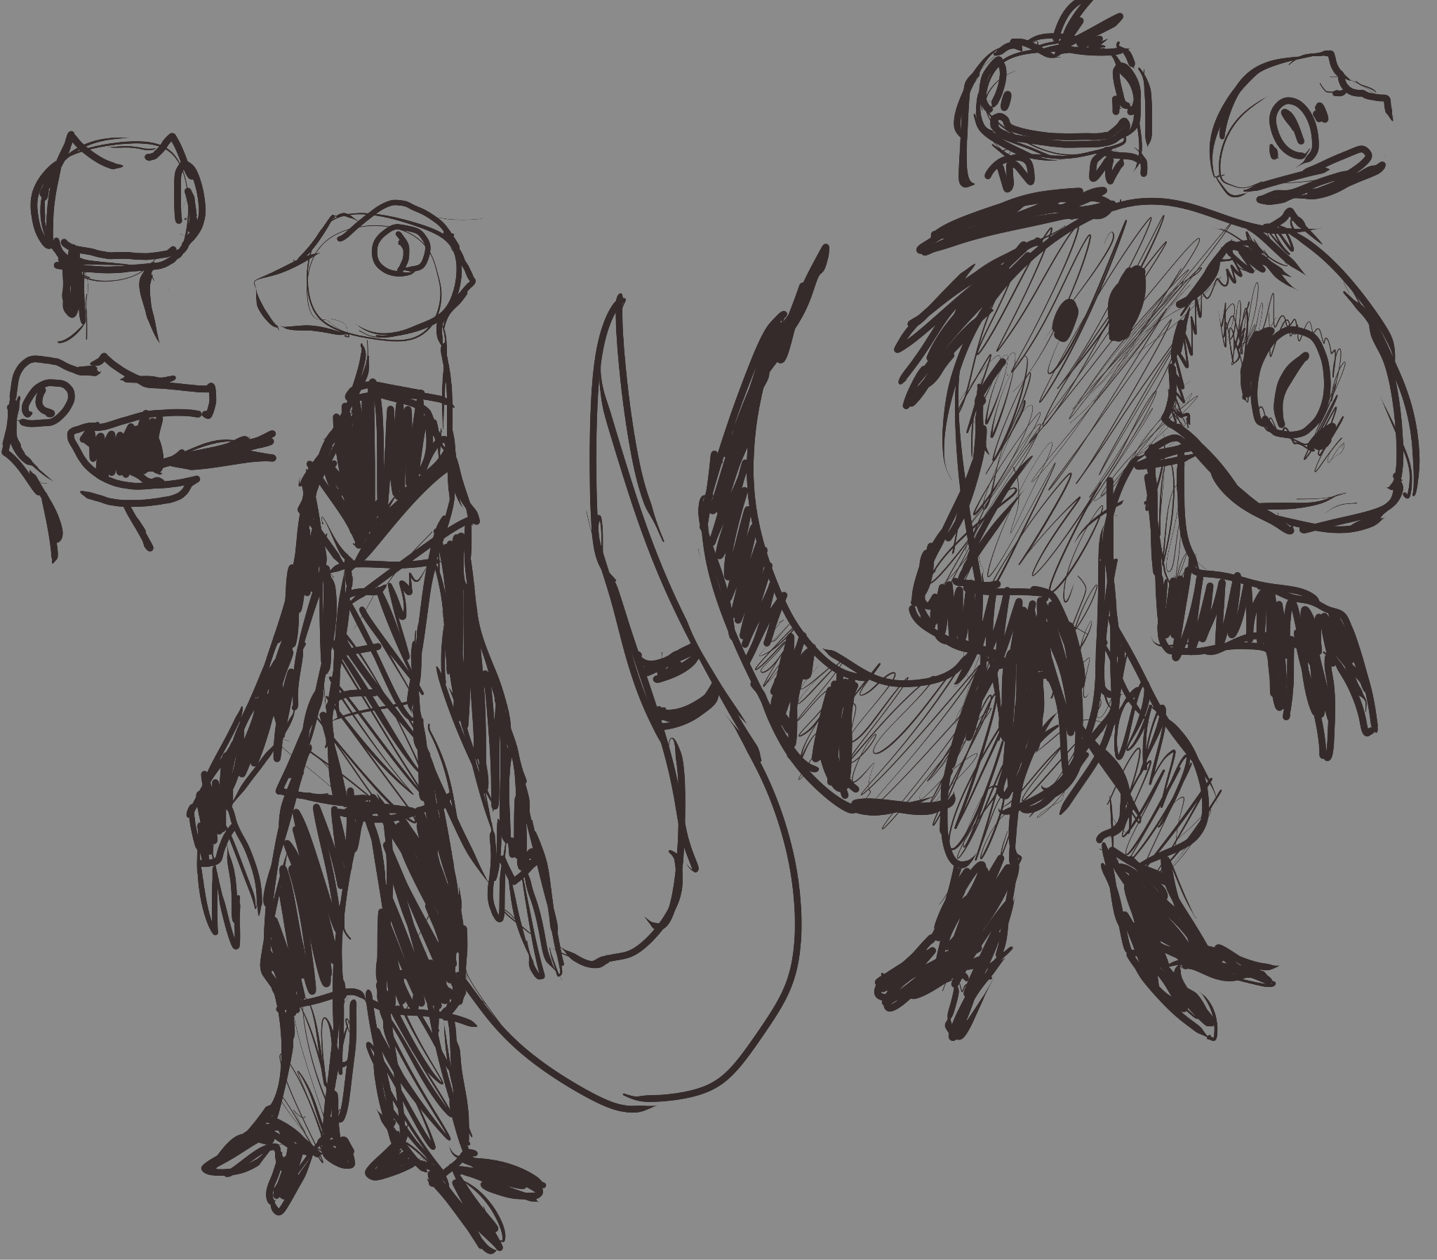

**Golem:**

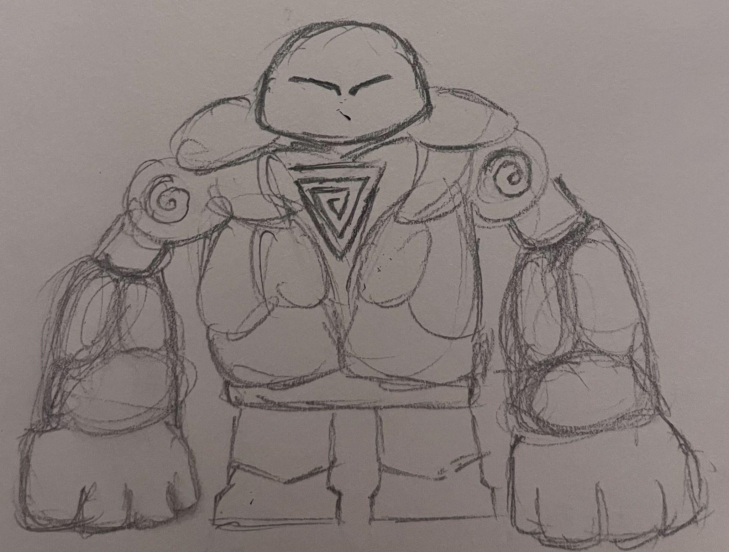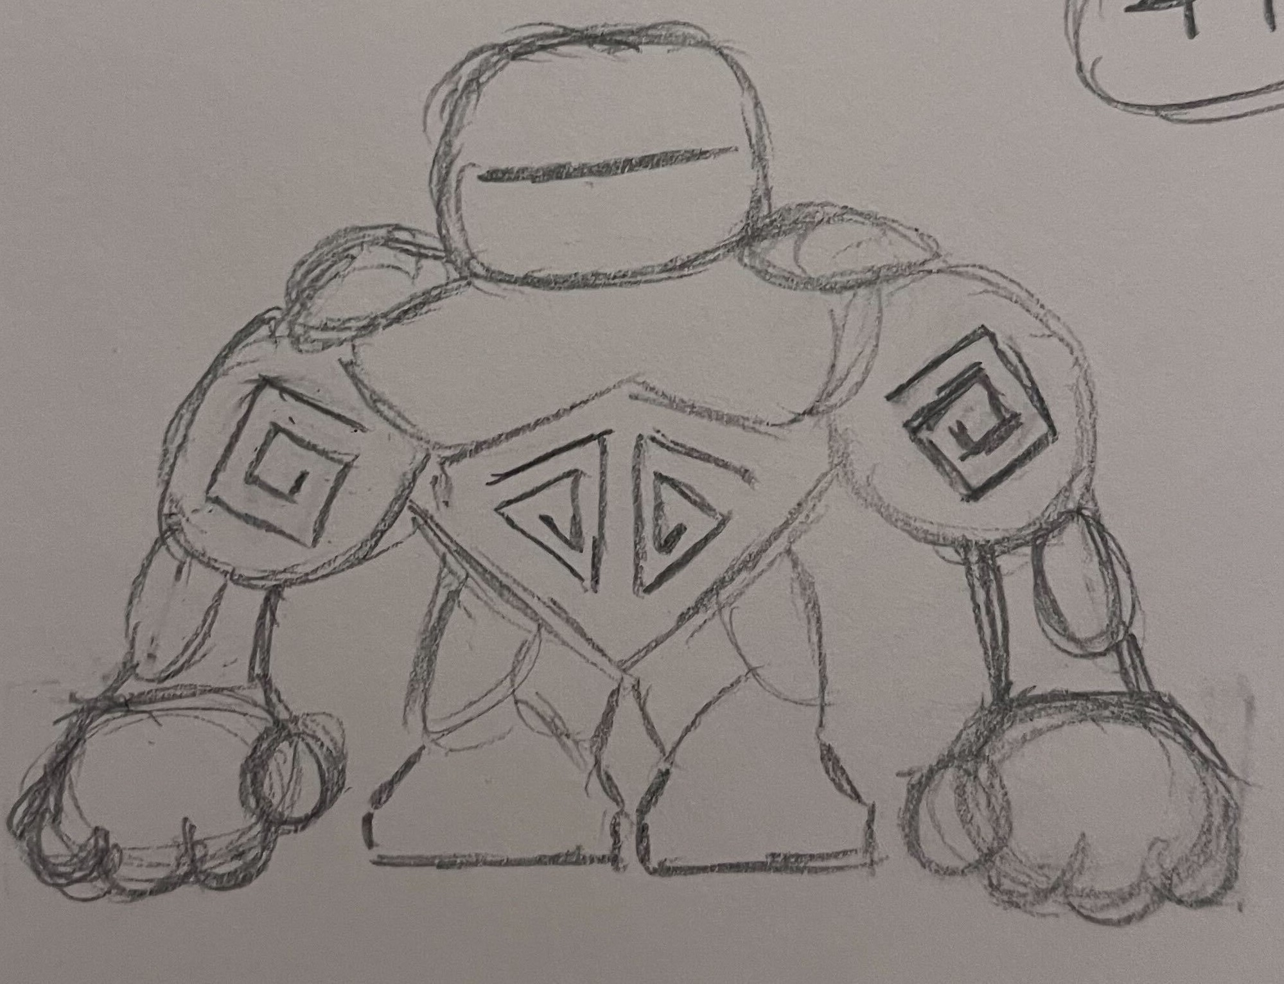

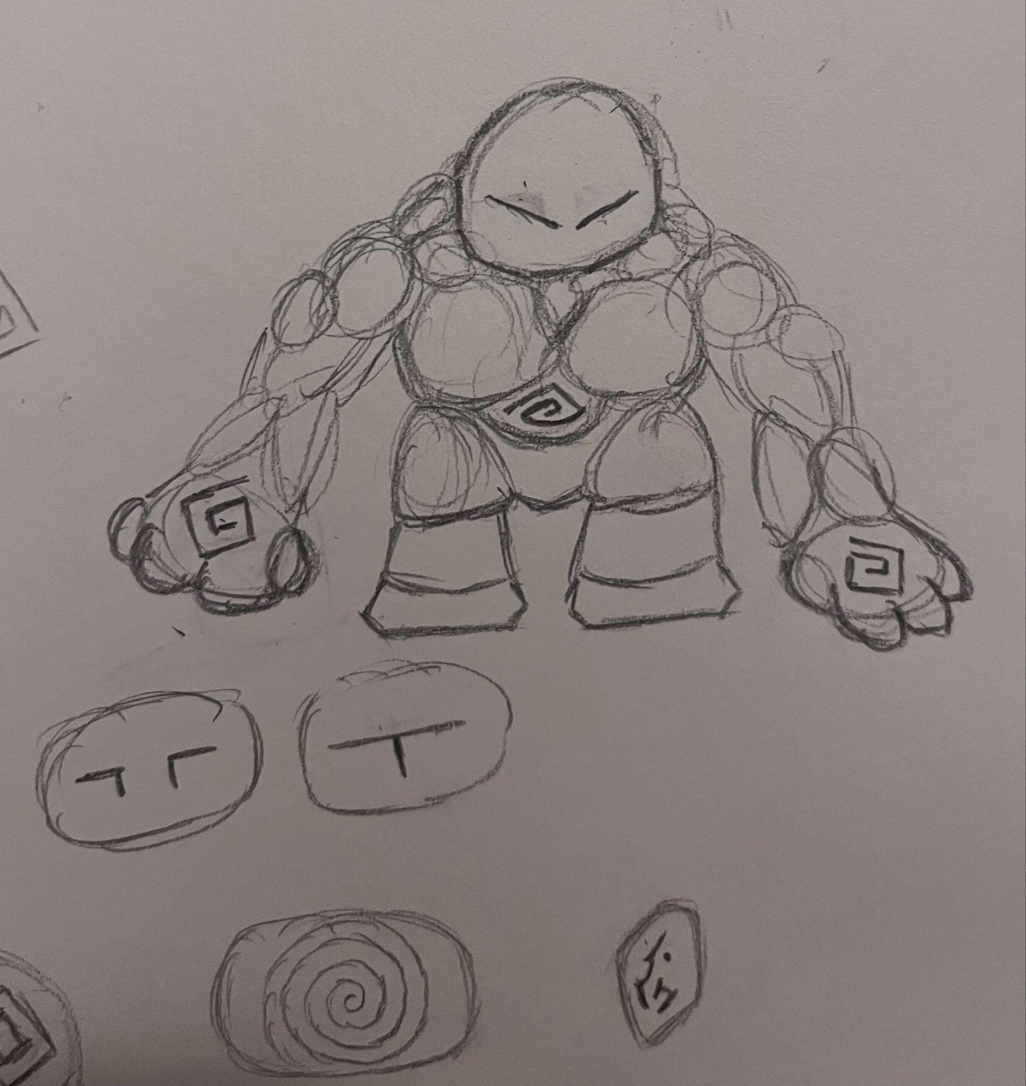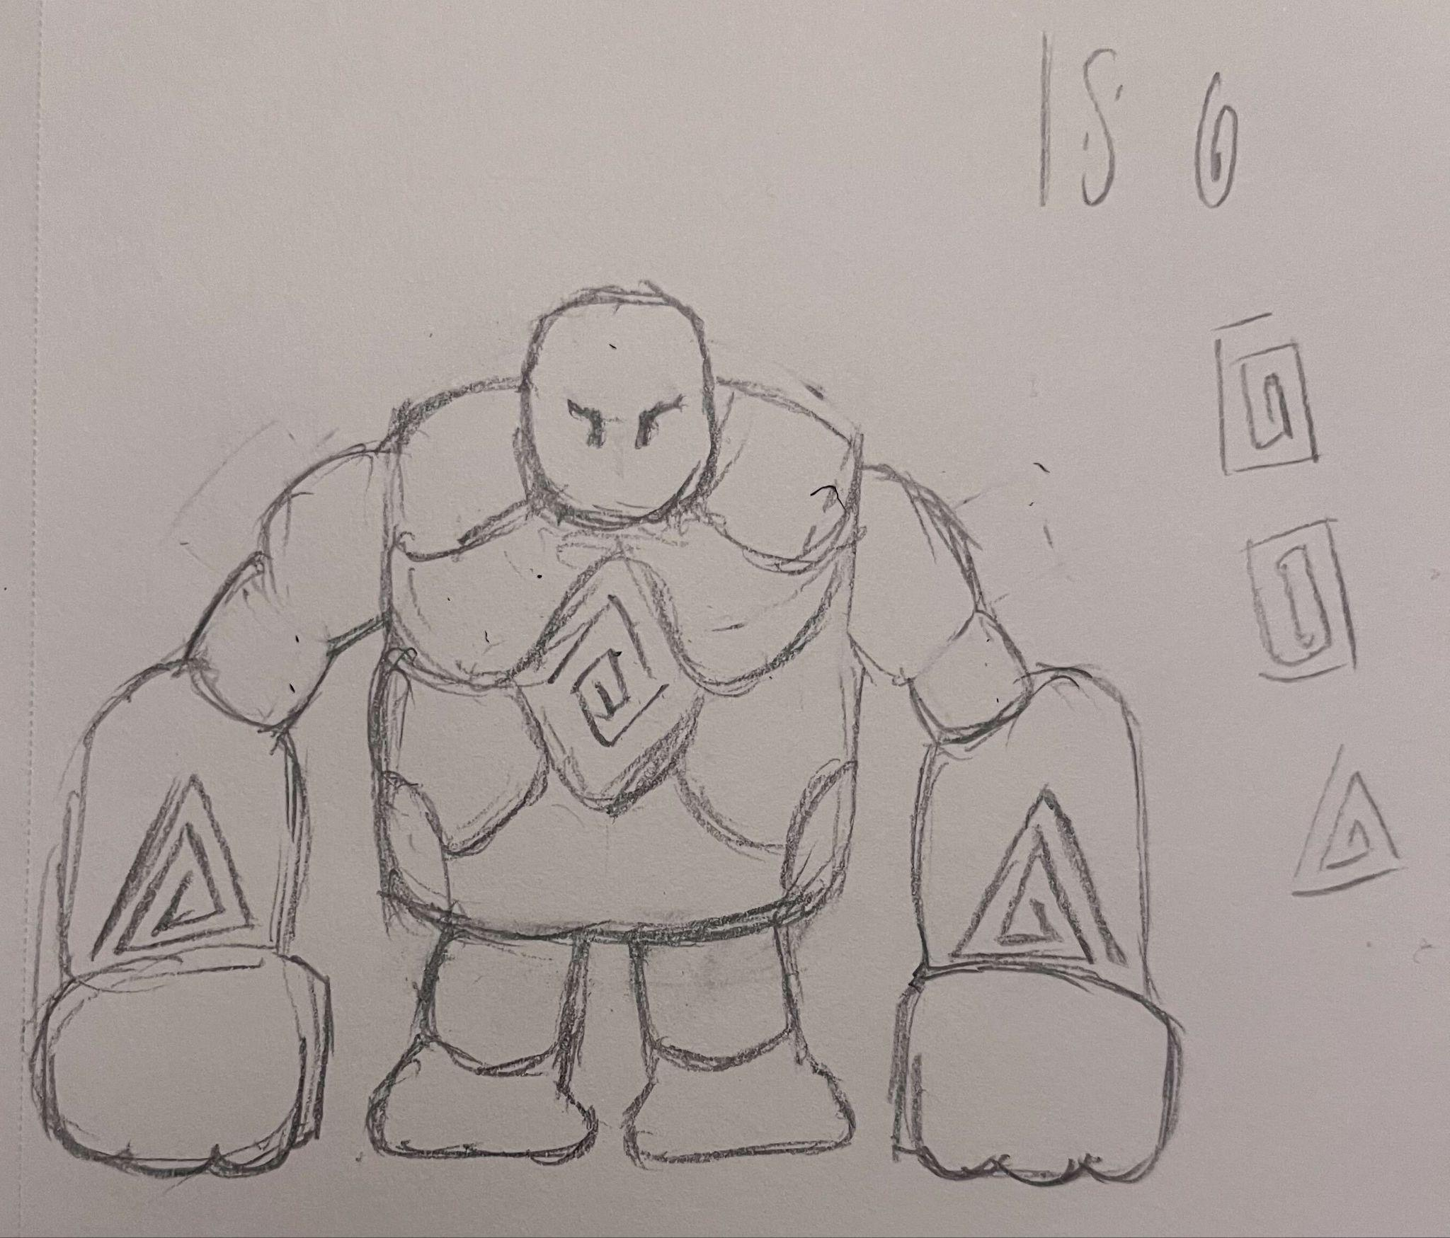

**Environment:**



